BOOK-9 FRONT PAGE

***NEED TO IMPROVE***

Cartoon size is not proper and blur also in all the pages.

Text is different as compared to original in all the pages.

Color of boxes is not and outlining is also not proper

Spelling mistake in ***bucher*** (two dots are not there in letter ***u***.

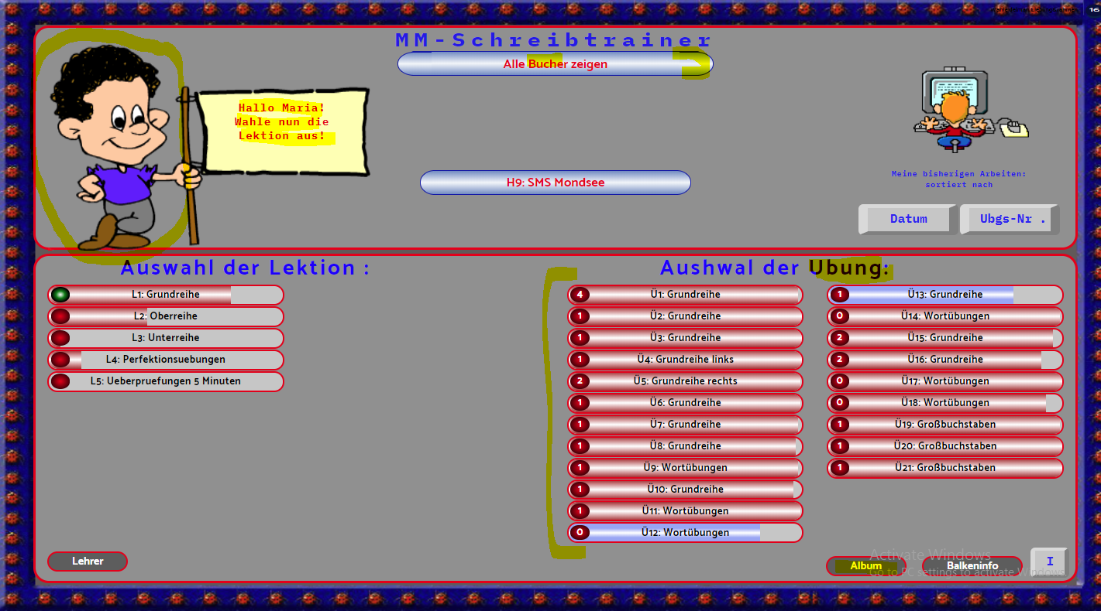

Album option is not working in this as compared to original

Dots are not there in letter ***“u”***

Color of unit boxes is also not same as compared to original (all the pages are same bug).

Programmende option is not there as compared to original

Percentage of colors in the boxes of units are also not same(all pages have same bug).

***ORIGINAL***

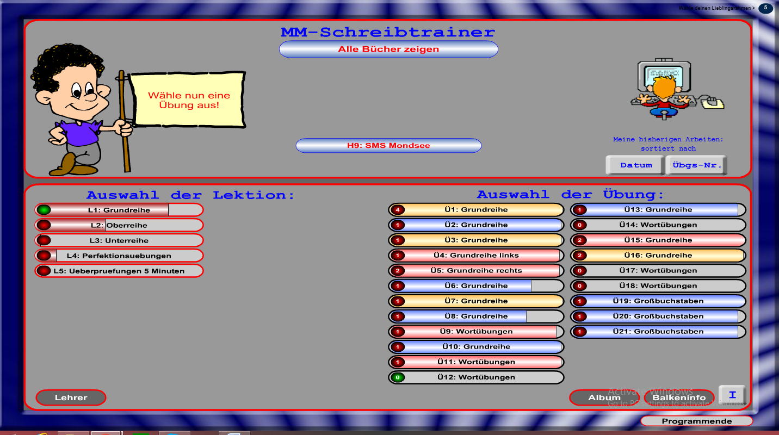

***LESSON-1***

BOOK-9 LESSON-1 UNIT-1

***NEED TO IMPROVE***

Cartoon is not there in the original

Unit no is not mention there as compared to original

This white boxes are not in the original

Font is not same

This text box is not showing in the original

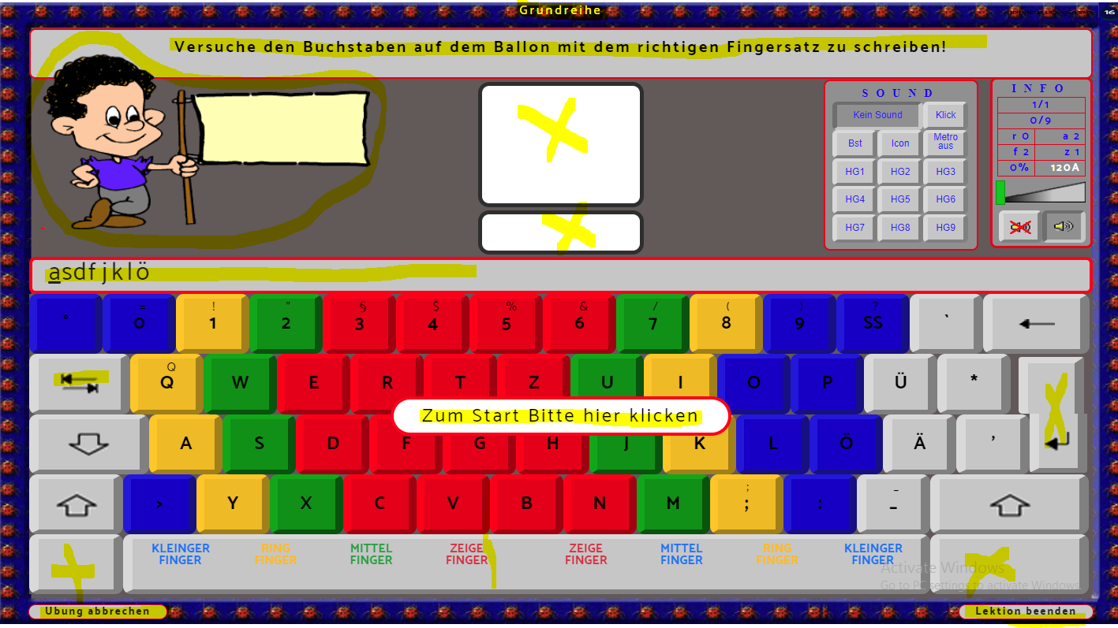

This text box is not showing in the original

Design of this button is not proper

Not working properly

There is no text and red line there as compared to original

This button is not working

This button is not working

These arrows are blur as compared to original

This button is not working

Game is totally different see above

This result window is not showing in the above which we need to improve

***ORIGINAL:***

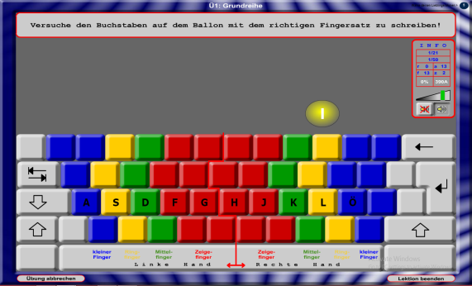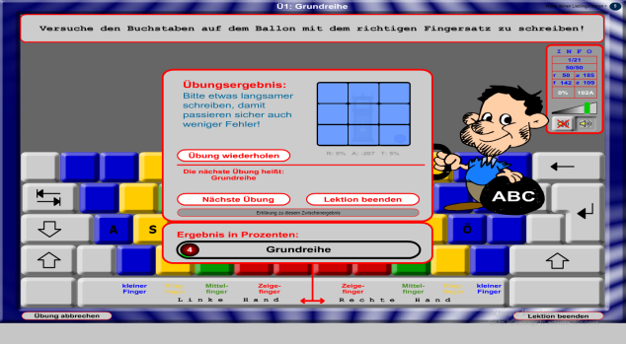

BOOK-9 LESSON-1 UNIT-2

***NEED TO IMPROVE***

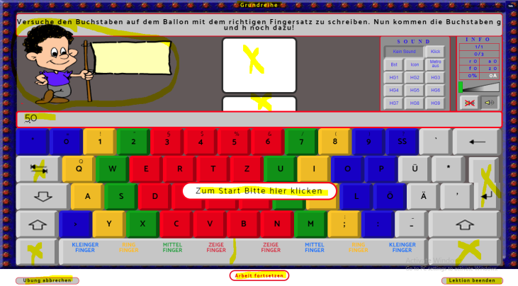

BUGS ARE SAME AS IN THE ABOVE UNIT 1

***ORIGINAL***

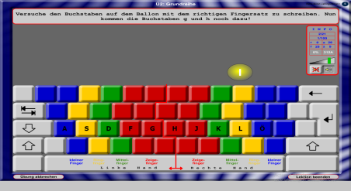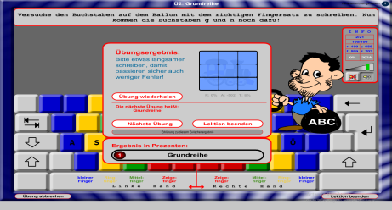

BOOK-9 LESSON-1 UNIT-3

***NEED TO IMPROVE***

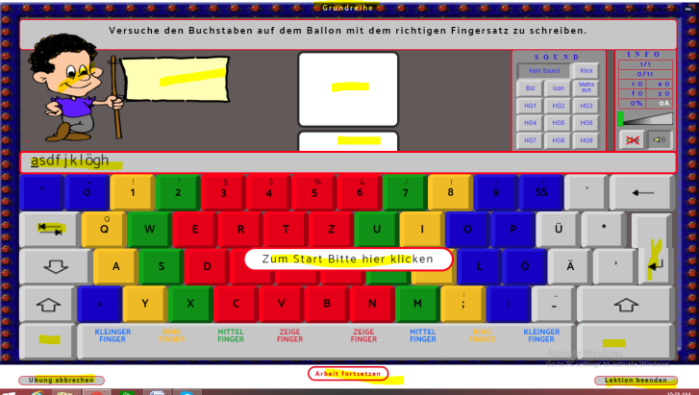

Bugs are same as in unit 1 and it shows the text above the keyboard instead of bubbles as we see in original and in original when game finishes it shows the result window also but in this it is not showing that result window

***ORIGINAL***

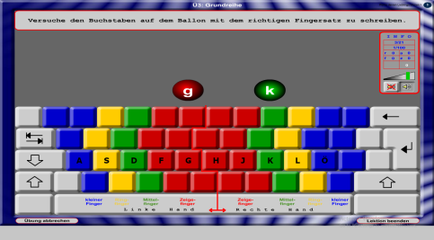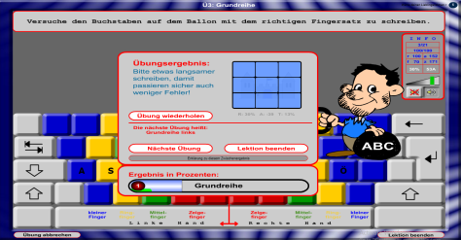

This is the result window which is not shown above

BOOK-9 LESSON-1 UNIT-4

***NEED TO IMPROVE***

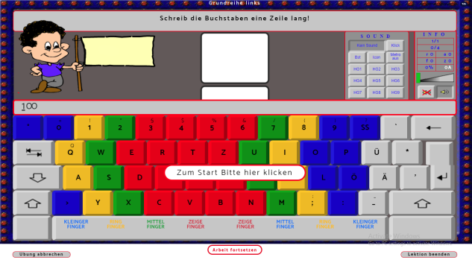

Screen is totally different as compared to original below (so this page should have content like below picture)

***ORIGINAL***

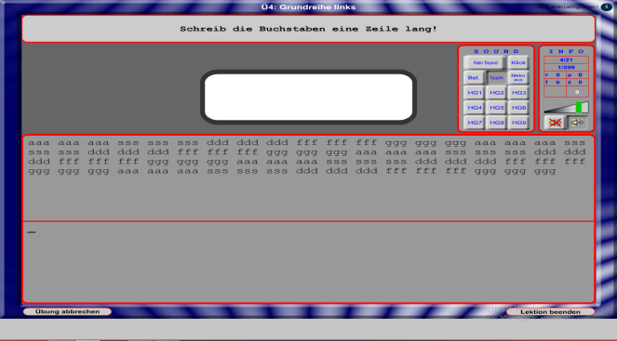

BOOK-9 LESSON-1 UNIT-5

***NEED TO IMPROVE***

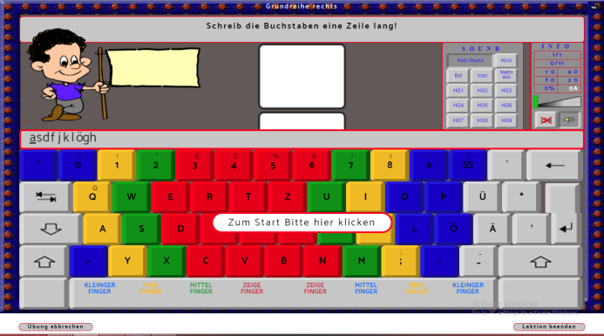

This is showing keyboard instead of content which is shown in below picture

This volume key is not working properly as compared to original below

***ORIGINAL***

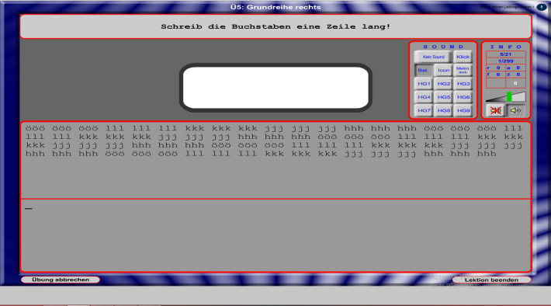

BOOK-9 LESSON-1 UNIT-6

***NEED TO IMPROVE ORIGINAL***

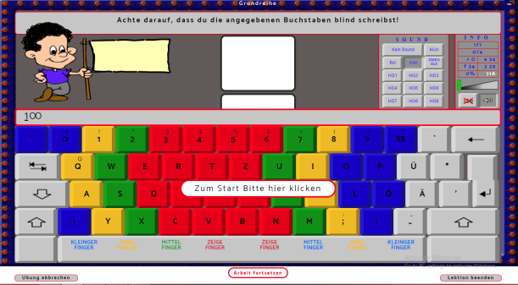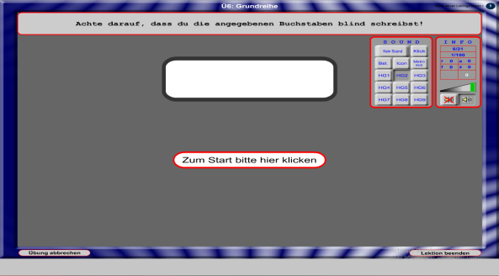

This is showing a keyboard instead of content like in original

BOOK-9 LESSON-1 UNIT-7

***NEED TO IMPROVE ORIGINAL***

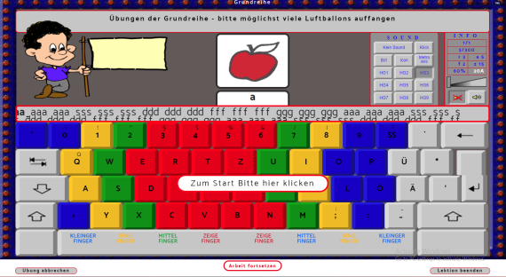 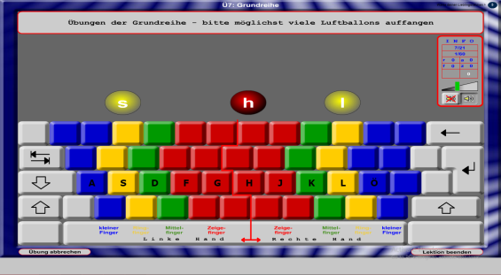

This is showing the different content and no result widow is there after the completion of the game as compared to original

BOOK-9 LESSON-1 UNIT-8

***NEED TO IMPROVE ORIGINAL***

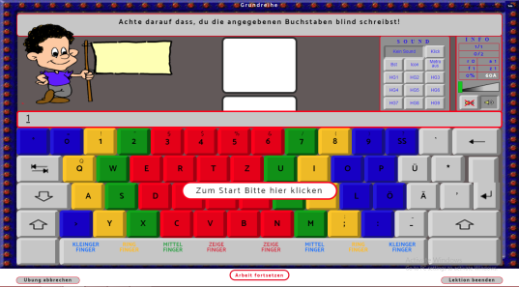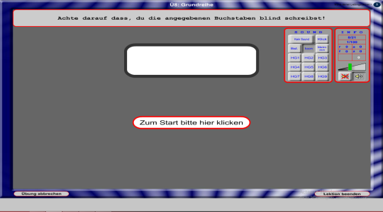

Both are different as shown above

BOOK-9 LESSON-1 UNIT-9

***NEED TO IMPROVE ORIGINAL***

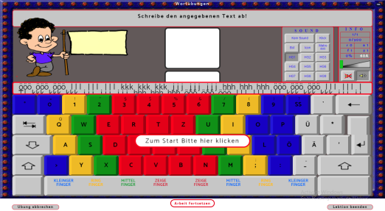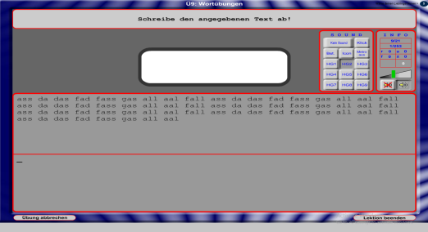

Both are different. Screen is totally different as compared to original

BBOK-9 LESSON-1 UNIT-10

***NEED TO IMPROVE ORIGINAL***

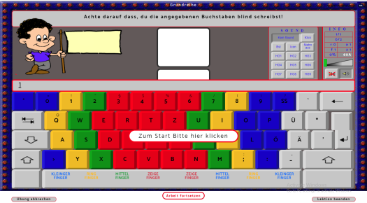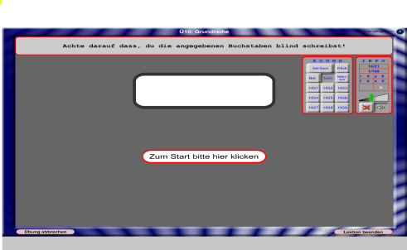

Both are different. Screen is totally different as compared to original

BOOK-9 LESSON-1 UNIT-11

***NEED TO IMPROVE ORIGINAL***

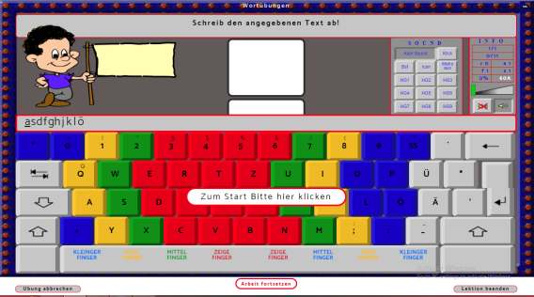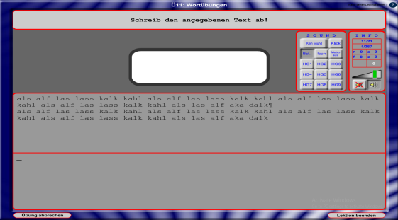

Both are different. Screen is totally different as compared to original

BOOK-9 LESSON-1 UNIT-12

***NEED TO IMPROVE ORIGINAL***

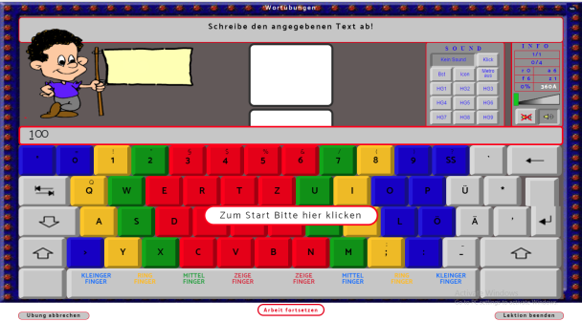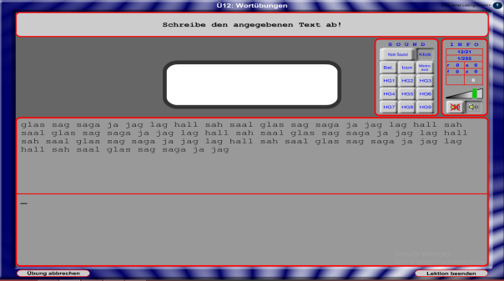

Both are different. Screen is totally different as compared to original

BOOK-9 LESSON-1 UNIT-13

***NEED TO IMPROVE ORIGINAL***

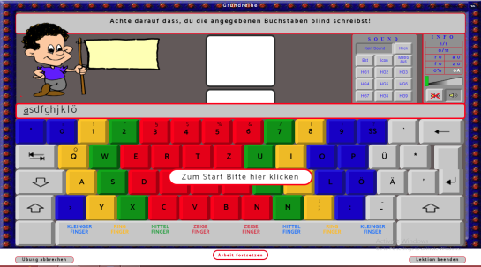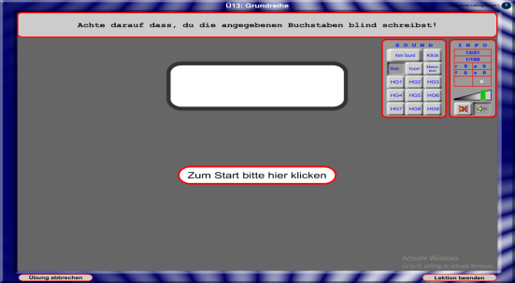

Both are different. Screen is totally different as compared to original

Screen is totally different as compared to original

BOOK-9 LESSON-1 UNIT-14

***NEED TO IMPROVE ORIGINAL***

Both are different. Screen is totally different as compared to original

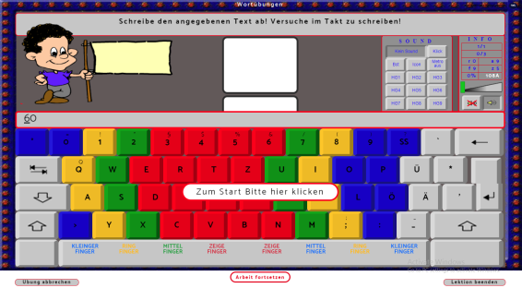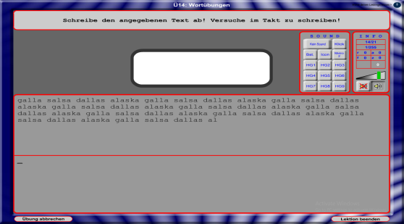

BOOK-9 LESSON-1 UNIT-15

***NEED TO IMPROVE ORIGINAL***

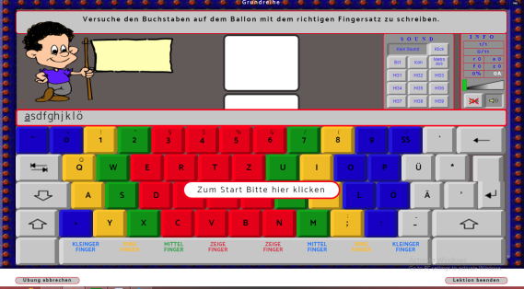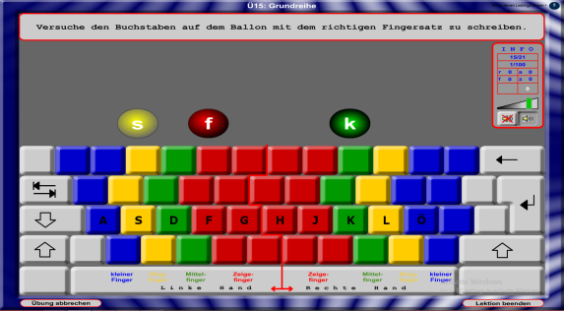

Both are different. Screen is totally different as compared to original

BOOK-9 LESSON-1 UNIT-16

***NEED TO IMPROVE ORIGINAL***

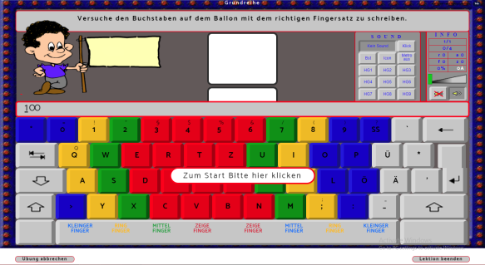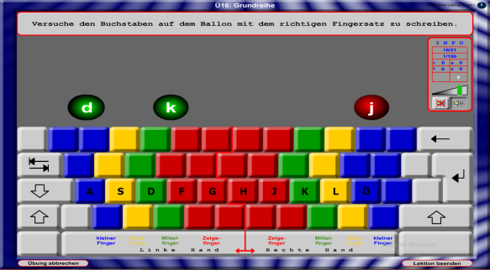

Both are different. Screen is totally different as compared to original

BOOK-9 LESSON-1 UNIT-17

***NEED TO IMPROVE ORIGINAL***

Both are different. Screen is totally different as compared to original

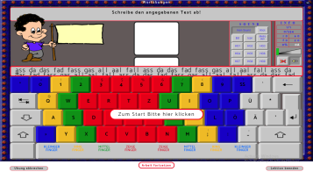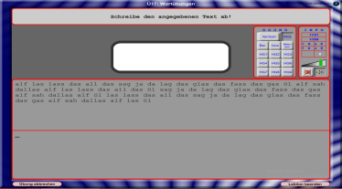

BOOK-9 LESSON-1 UNIT-18

***NEED TO IMPROVE ORIGINAL***

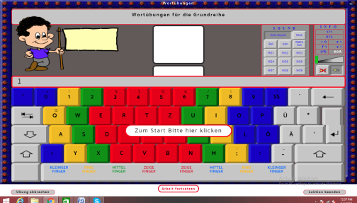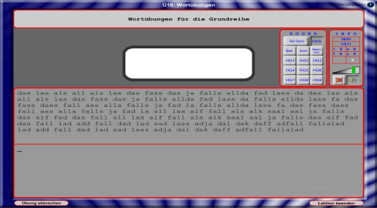

Both are different. Screen is totally different as compared to original

BOOK-9 LESSON-1 UNIT-19

***NEED TO IMPROVE ORIGINAL***

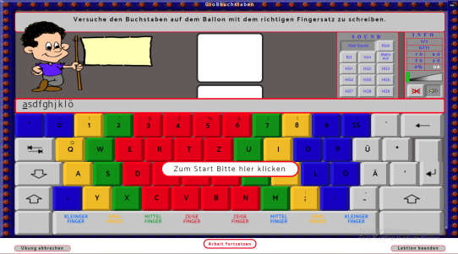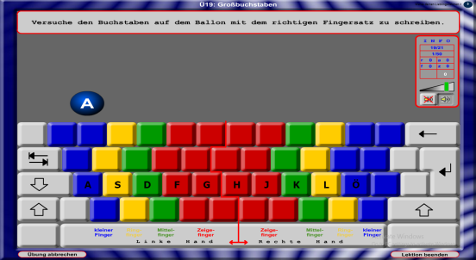

Both are different. Screen is totally different as compared to original

BOOK-9 LESSON-1 UNIT-20

***NEED TO IMPROVE ORIGINAL***

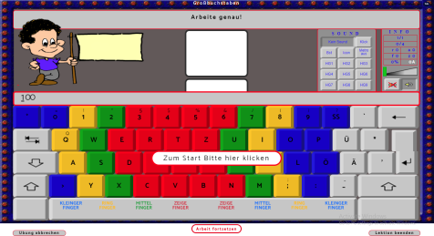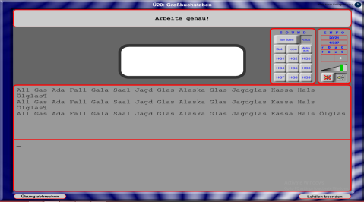

Both are different. Screen is totally different as compared to original

BOOK-9 LESSON-1 UNIT-21

***NEED TO IMPROVE*** ***ORIGINAL***

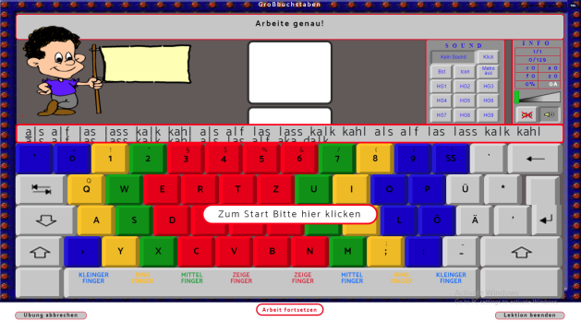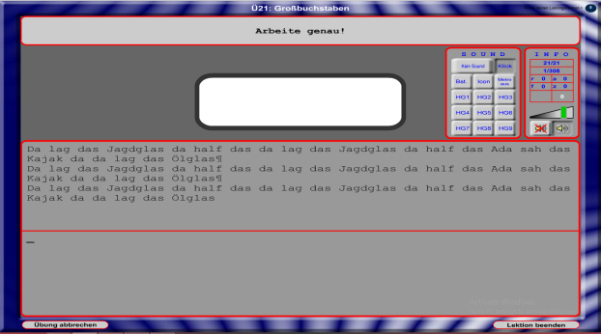

Both are different. Screen is totally different as compared to original

BOOK-9 LESSON-2 UNIT-1

***NEED TO IMPROVE ORIGINAL***

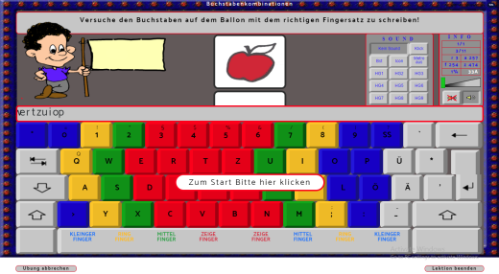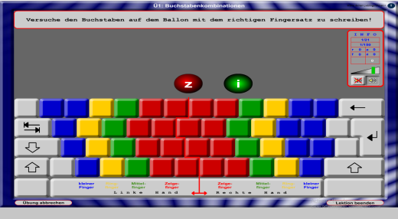

Both are different. Screen is totally different as compared to original

BOOK-9 LESSON-2 UNIT-2

***NEED TO IMPROVE ORIGINAL***

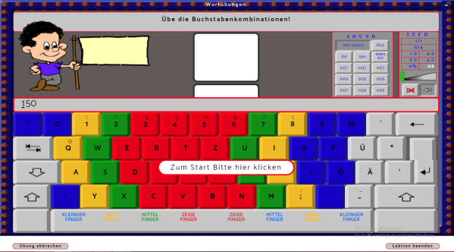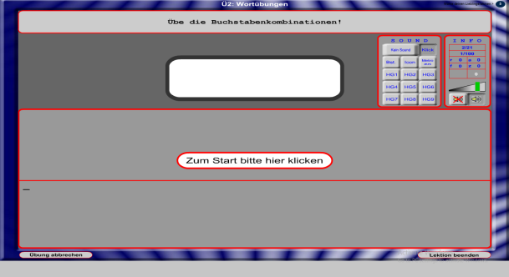

Both are different. Screen is totally different as compared to original

BOOK-9 LESSON-2 UNIT-3

***NEED TO IMPROVE ORIGINAL***

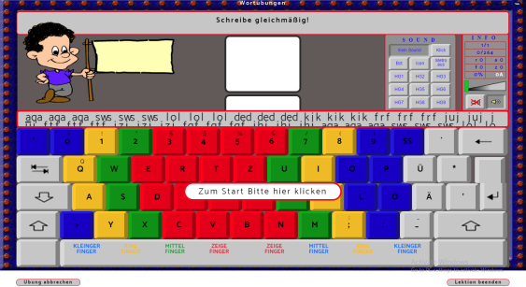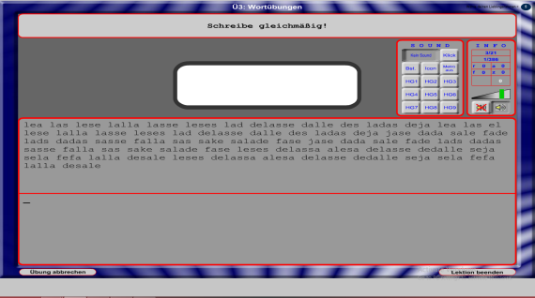

Both are different. Screen is totally different as compared to original

BOOK-9 LESSON-2 UNIT-4

***NEED TO IMPROVE ORIGINAL***

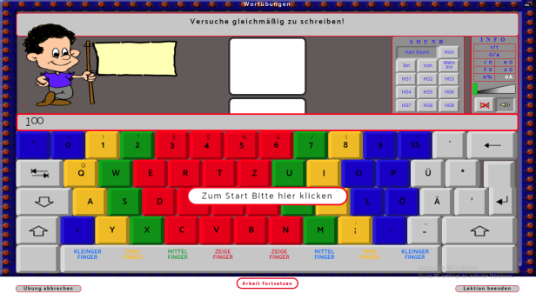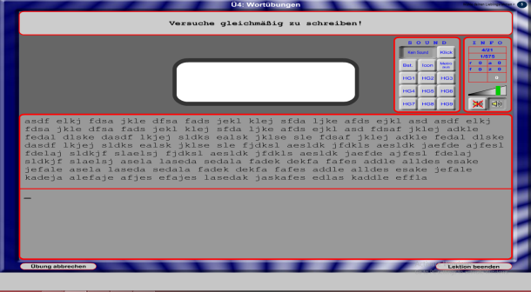

Both are different. Screen is totally different as compared to original

BOOK-9 LESSON-2 UNIT-5

***NEED TO IMPROVE ORIGINAL***

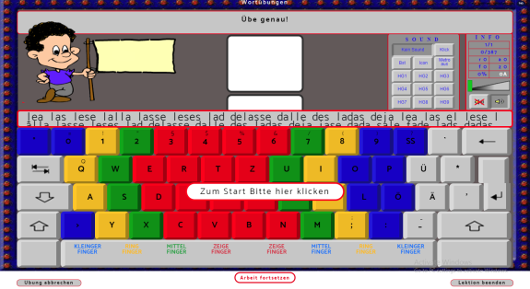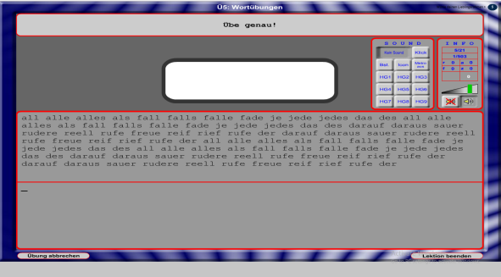

Both are different. Screen is totally different as compared to original

BOOK-9 LESSON-2 UNIT-6

***NEED TO IMPROVE ORIGINAL***

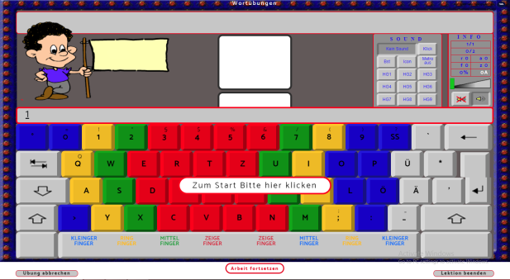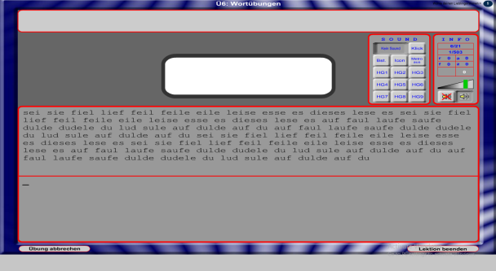

Both are different. Screen is totally different as compared to original

BOOK-9 LESSON-2 UNIT-7

***NEED TO IMPROVE ORIGINAL***

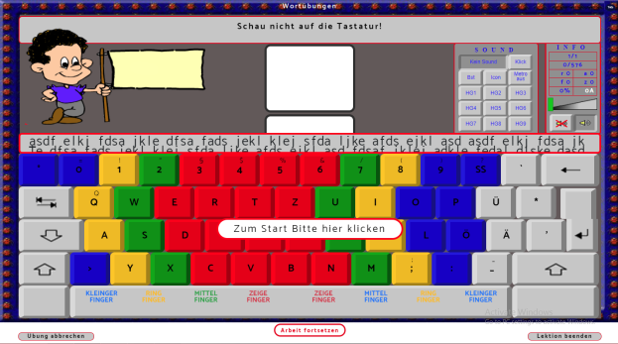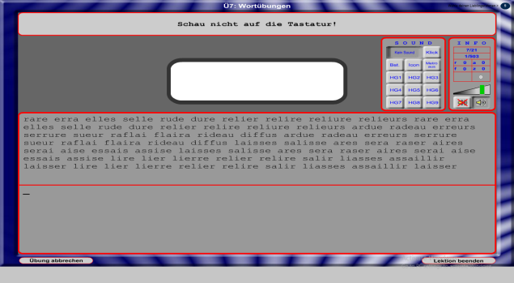

Both are different. Screen is totally different as compared to original

BOOK-9 LESSON-2 UNIT-8

***NEED TO IMPROVE ORIGINAL***

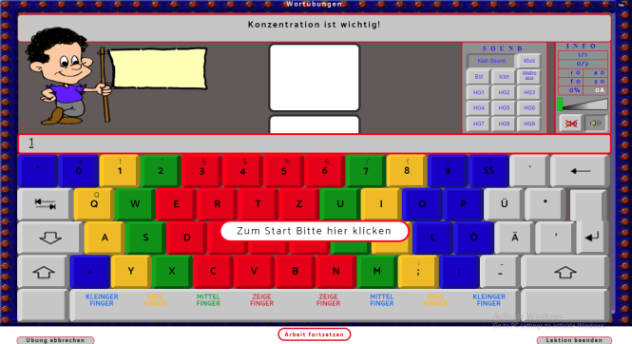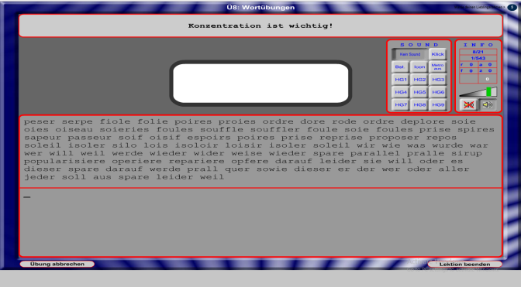

Both are different. Screen is totally different as compared to original

BOOK-9 LESSON-2 UNIT-9

***NEED TO IMPROVE ORIGINAL***

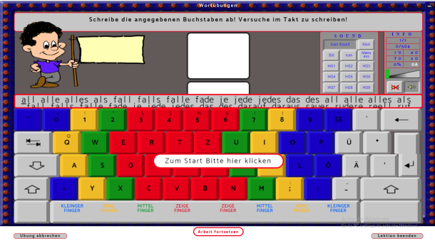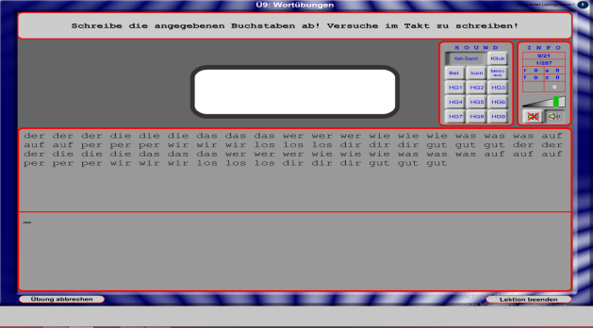

Both are different. Screen is totally different as compared to original

BOOK-9 LESSON-2 UNIT-10

***NEED TO IMPROVE ORIGINAL***

Both are different. Screen is totally different as compared to original

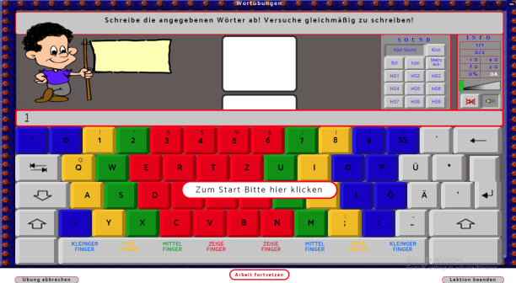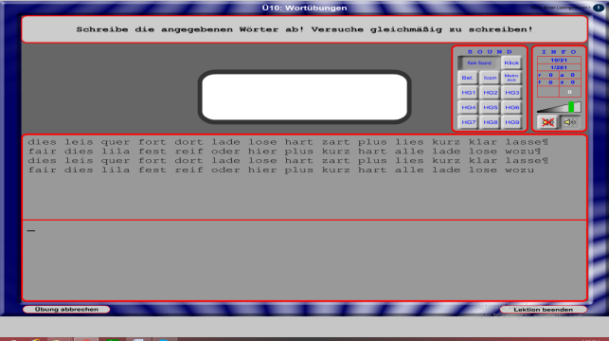

BOOK-9 LESSON-2 UNIT-11

***NEED TO IMPROVE ORIGINAL***

Both are different. Screen is totally different as compared to original

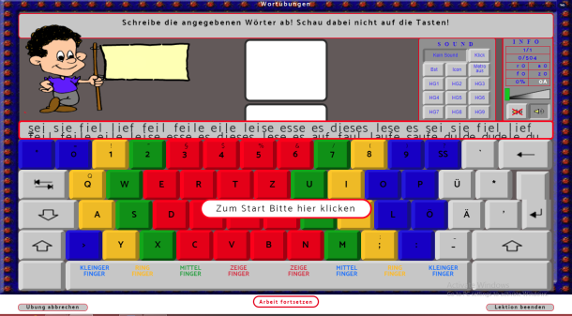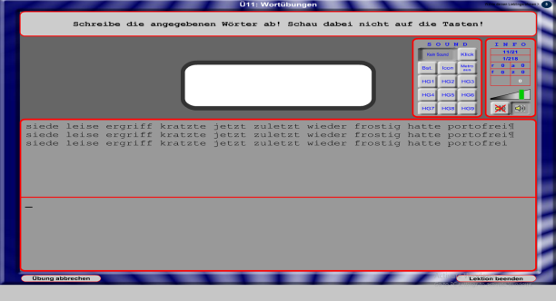

BOOK-9 LESSON-2 UNIT-12

***NEED TO IMPROVE ORIGINAL***

Both are different. Screen is totally different as compared to original

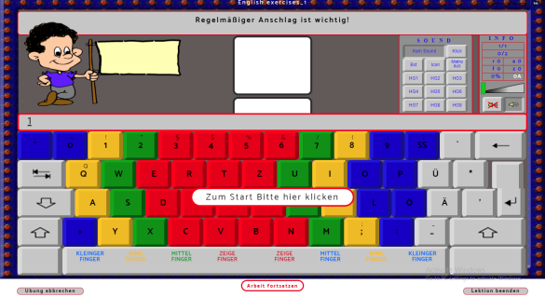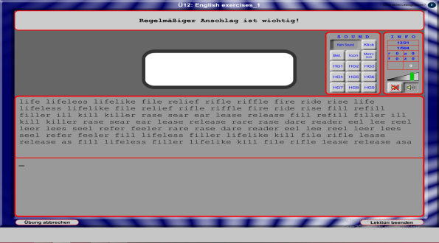

BOOK-9 LESSON-2 UNIT-13

***NEED TO IMPROVE ORIGINAL***

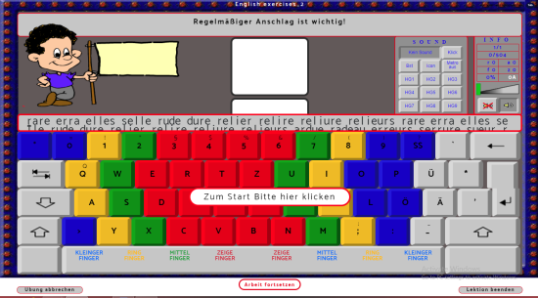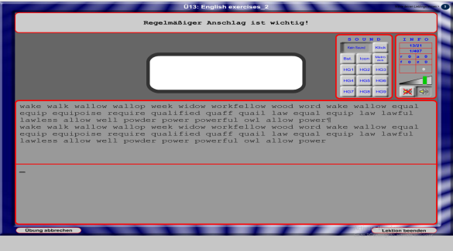

Both are different. Screen is totally different as compared to original

BOOK-9 LESSON-2 UNIT-14

***NEED TO IMPROVE ORIGINAL***

Both are different. Screen is totally different as compared to original

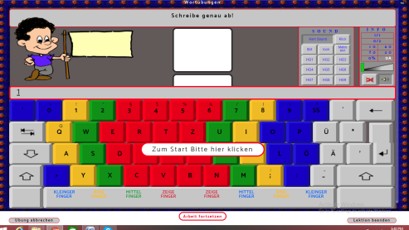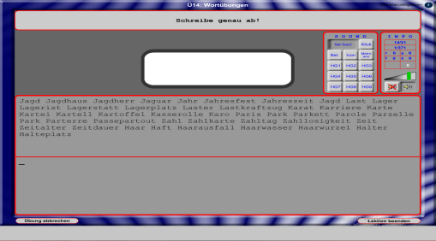

BOOK-9 LESSON-2 UNIT-15

***NEED TO IMPROVE ORIGINAL***

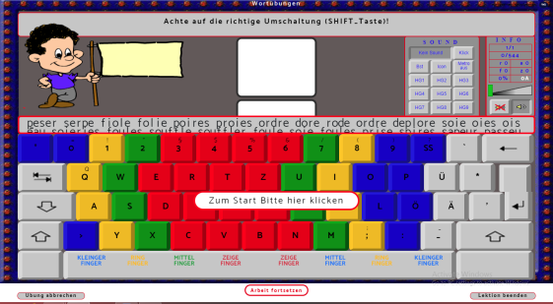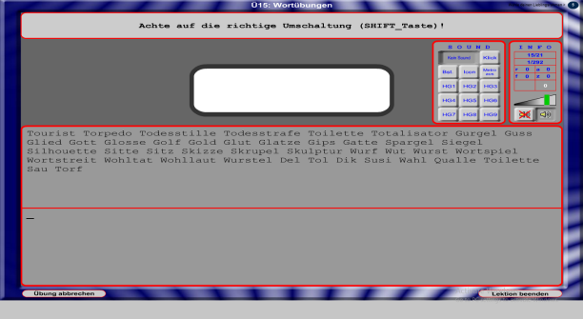

Both are different. Screen is totally different as compared to original

BOOK-9 LESSON-2 UNIT-16

***NEED TO IMPROVE ORIGINAL***

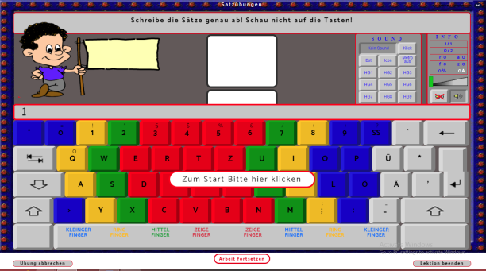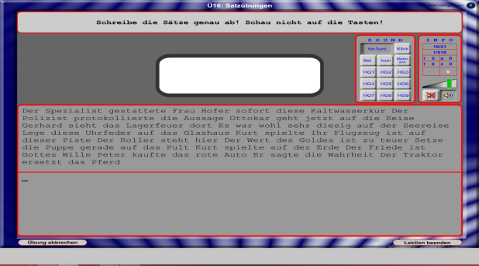

Both are different. Screen is totally different as compared to original

BOOK-9 LESSON-2 UNIT-17

***NEED TO IMPROVE ORIGINAL***

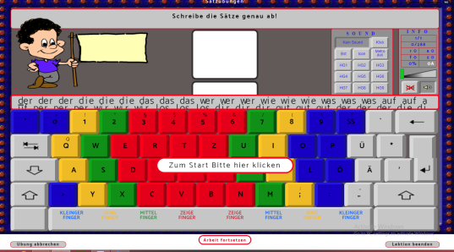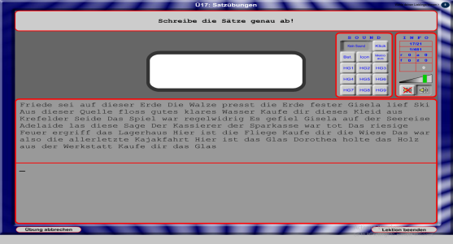

Both are different. Screen is totally different as compared to original

BOOK-9 LESSON-2 UNIT-18

***NEED TO IMPROVE ORIGINAL***

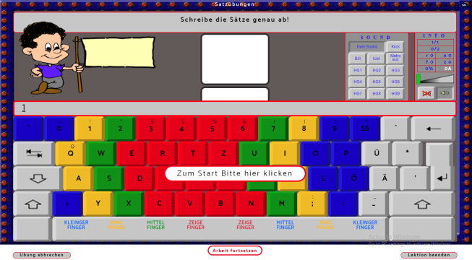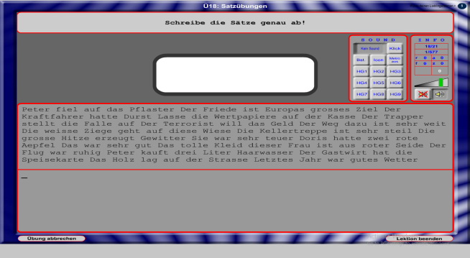

Both are different. Screen is totally different as compared to original

BOOK-9 LESSON-2 UNIT-19

***NEED TO IMPROVE ORIGINAL***

Both are different. Screen is totally different as compared to original

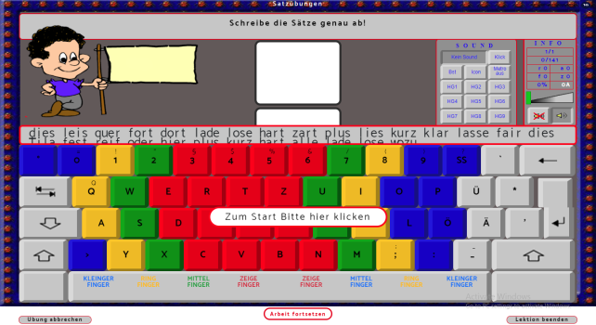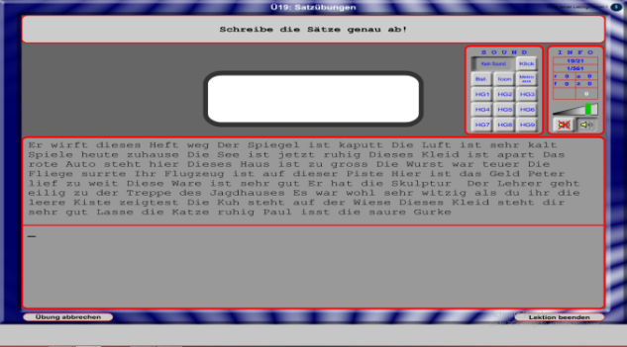

BOOK-9 LESSON-2 UNIT-20

***NEED TO IMPROVE ORIGINAL***

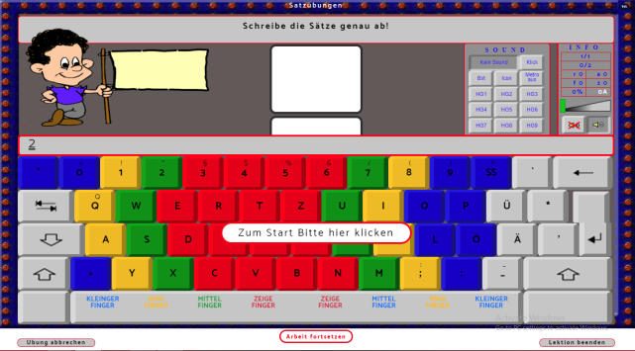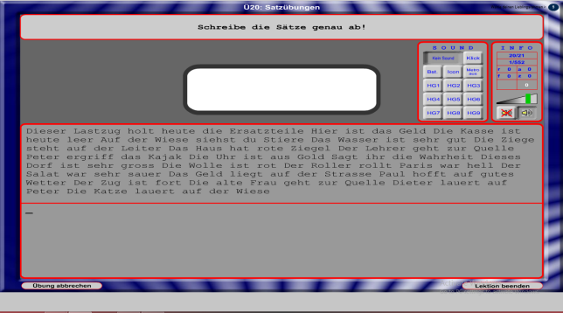

Both are different. Screen is totally different as compared to original

BOOK-9 LESSON-2 UNIT-21

***NEED TO IMPROVE ORIGINAL***

Both are different. Screen is totally different as compared to original

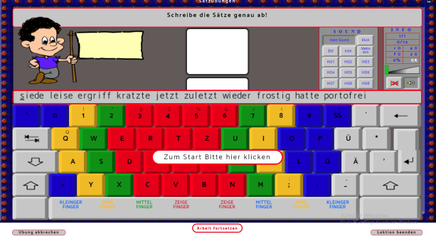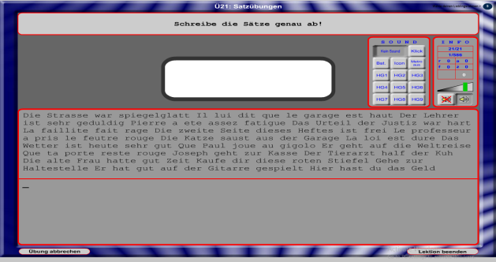

BOOK-9 LESSON-3 UNIT-1

***NEED TO IMPROVE ORIGINAL***

Both are different. Screen is totally different as compared to original

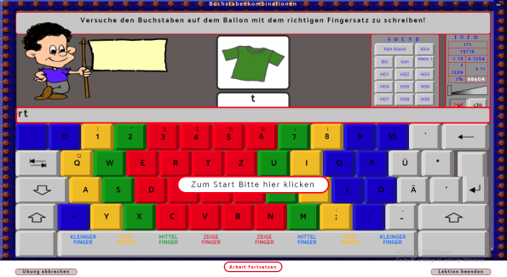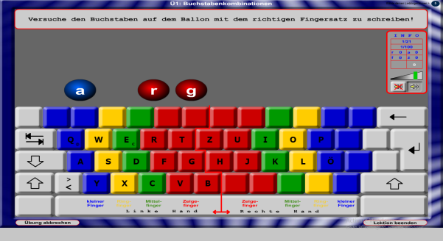

BOOK-9 LESSON-3 UNIT-2

***NEED TO IMPROVE ORIGINAL***

Both are different. Screen is totally different as compared to original

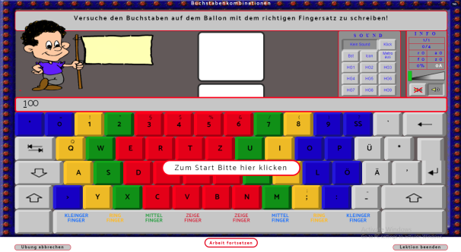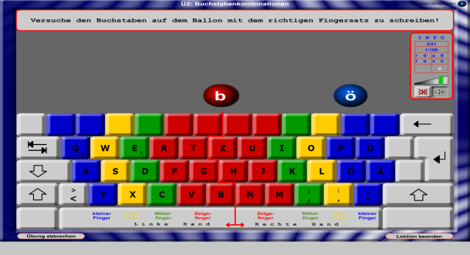

BOOK-9 LESSON-3 UNIT-3

***NEED TO IMPROVE ORIGINAL***

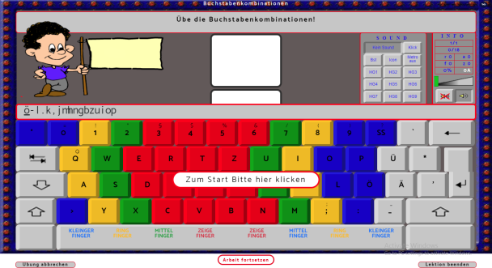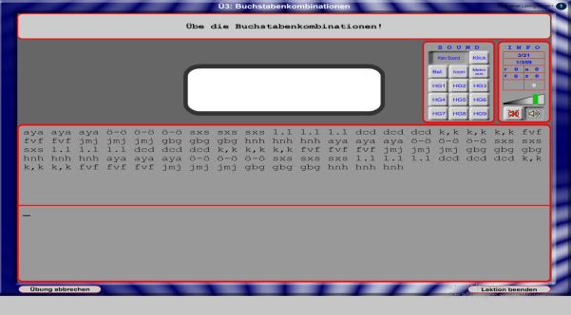

Both are different. Screen is totally different as compared to original

BOOK-9 LESSON-3 UNIT-4

***NEED TO IMPROVE ORIGINAL***

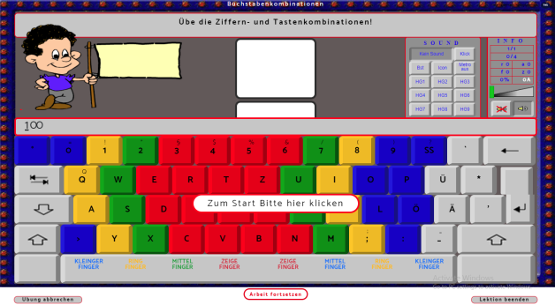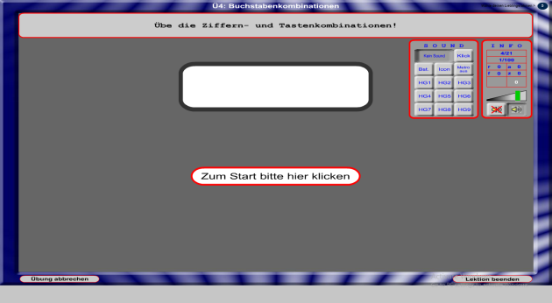

Both are different. Screen is totally different as compared to original

BOOK-9 LESSON-3 UNIT-5

***NEED TO IMPROVE ORIGINAL***

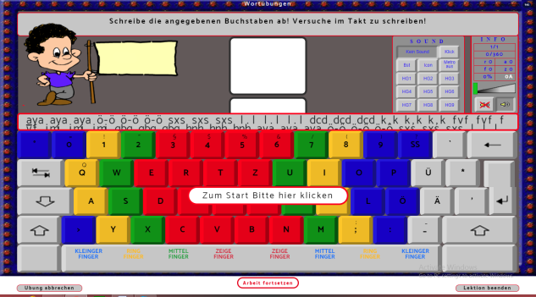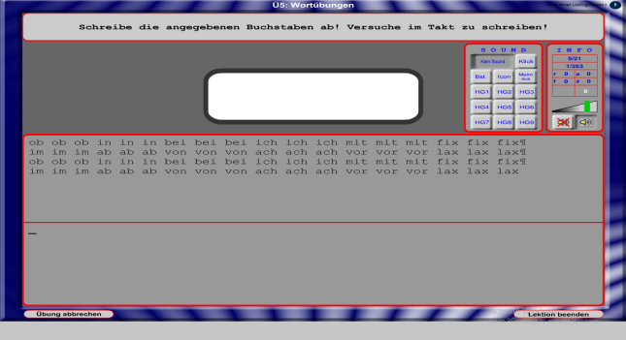

Both are different. Screen is totally different as compared to original

BOOK-9 LESSON-3 UNIT-6

***NEED TO IMPROVE ORIGINAL***

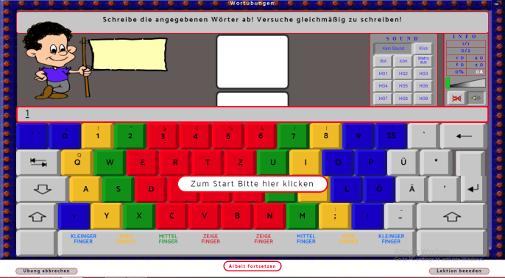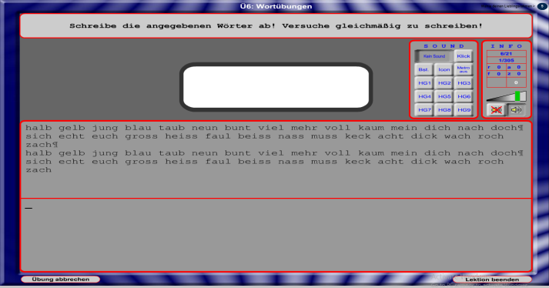

Both are different. Screen is totally different as compared to original

BOOK-9 LESSON-3 UNIT-7

***NEED TO IMPROVE ORIGINAL***

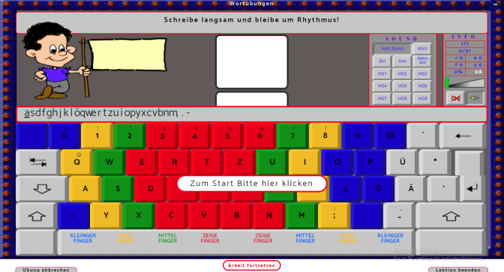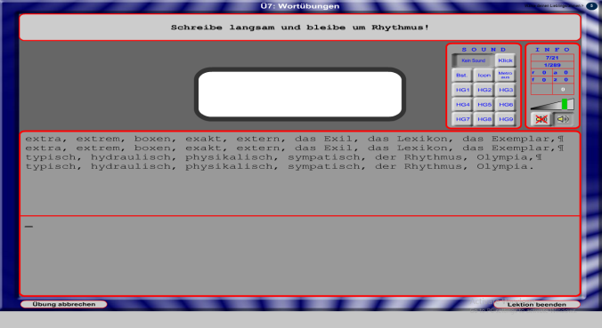

Both are different. Screen is totally different as compared to original

BOOK-9 LESSON-3 UNIT-8

***NEED TO IMPROVE ORIGINAL***

Both are different. Screen is totally different as compared to original

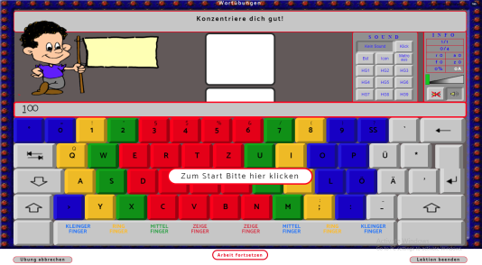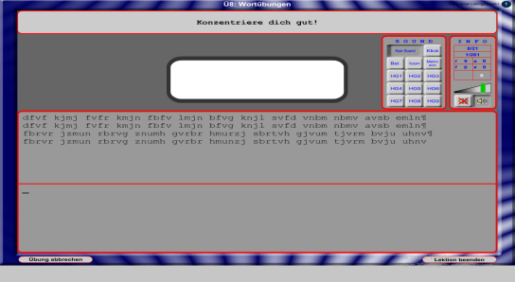

BOOK-9 LESSON-3 UNIT-9

***NEED TO IMPROVE ORIGINAL***

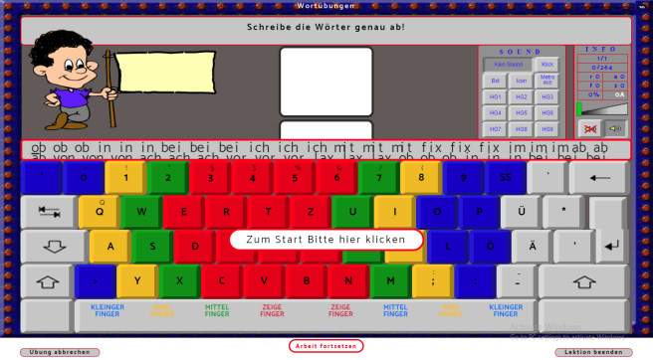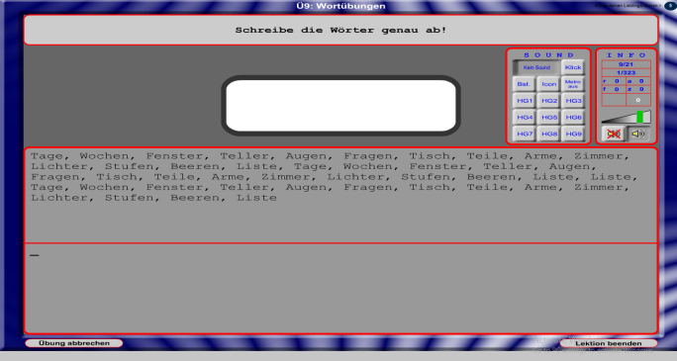

Both are different. Screen is totally different as compared to original

BOOK-9 LESSON-3 UNIT-10

***NEED TO IMPROVE ORIGINAL***

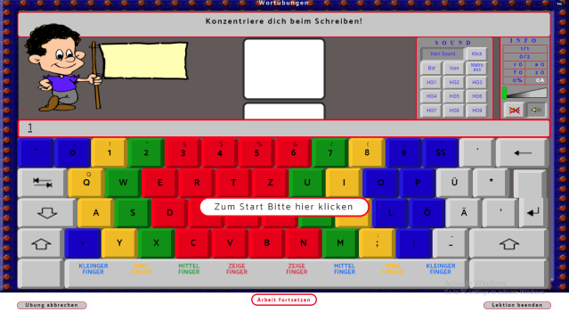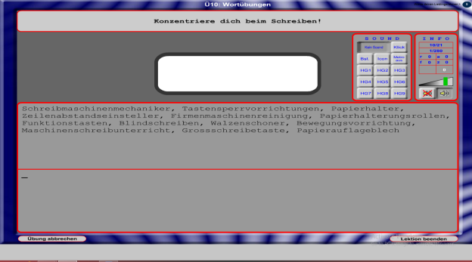

Both are different. Screen is totally different as compared to original

BOOK-9 LESSON-3 UNIT-11

***NEED TO IMPROVE ORIGINAL***

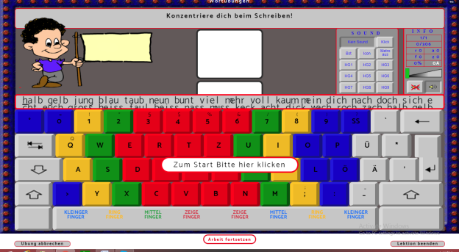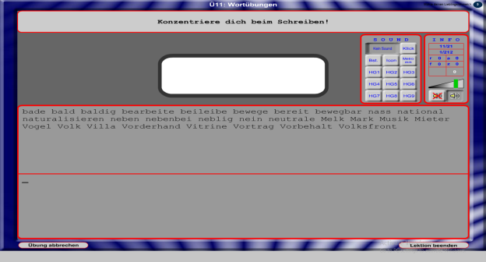

Both are different. Screen is totally different as compared to original

BOOK-9 LESSON-3 UNIT-12

***NEED TO IMPROVE ORIGINAL***

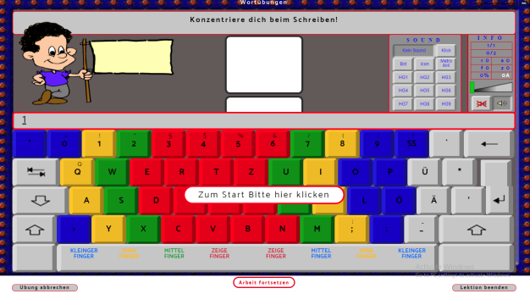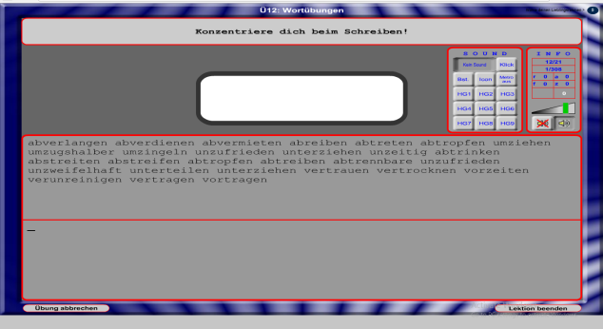

Both are different. Screen is totally different as compared to original

BOOK-9 LESSON-3 UNIT-13

***NEED TO IMPROVE ORIGINAL***

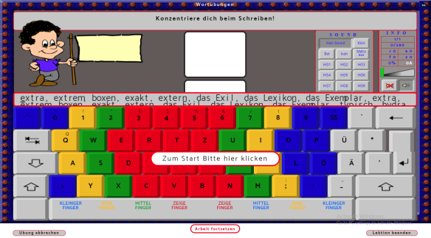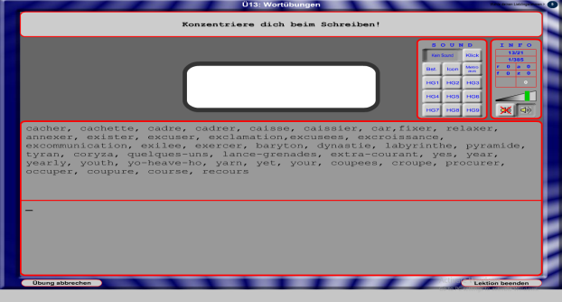

Both are different. Screen is totally different as compared to original

BOOK-9 LESSON-3 UNIT-14

***NEED TO IMPROVE ORIGINAL***

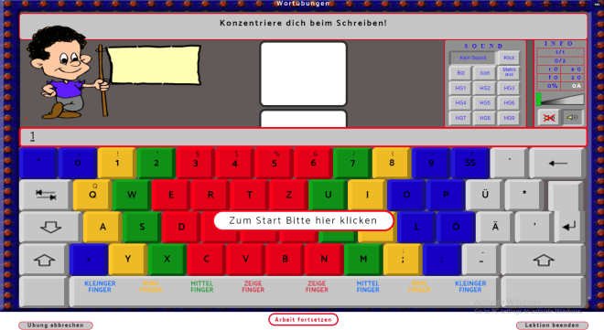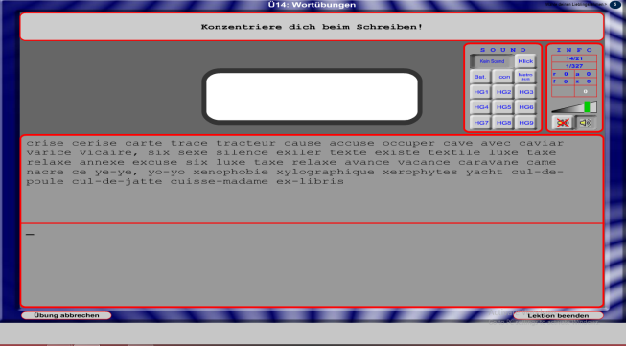

Both are different. Screen is totally different as compared to original

BOOK-9 LESSON-3 UNIT-15

***NEED TO IMPROVE ORIGINAL***

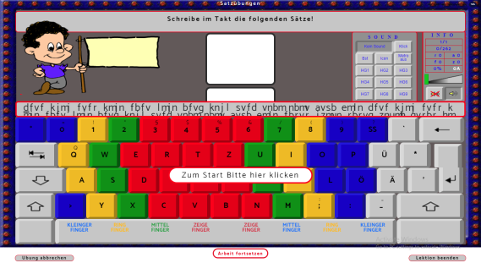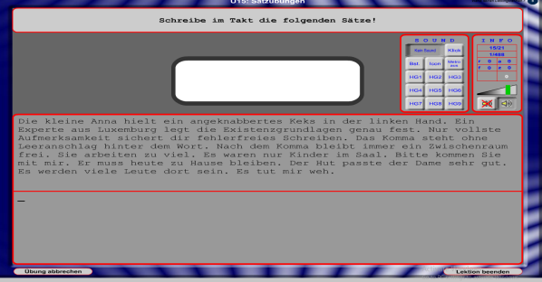

Both are different. Screen is totally different as compared to original

BOOK-9 LESSON-3 UNIT-16

***NEED TO IMPROVE ORIGINAL***

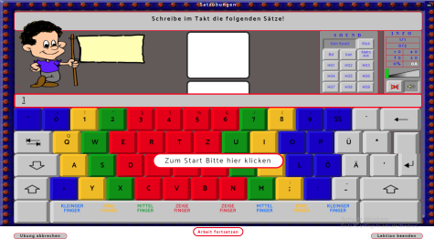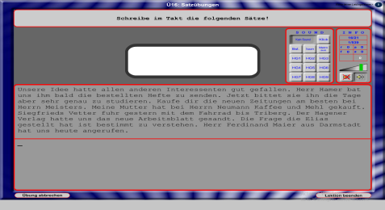

Both are different. Screen is totally different as compared to original

BOOK-9 LESSON-3 UNIT-17

***NEED TO IMPROVE ORIGINAL***

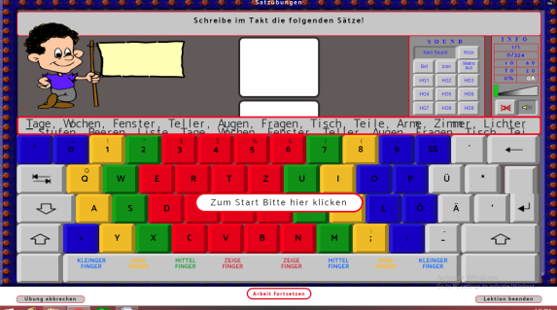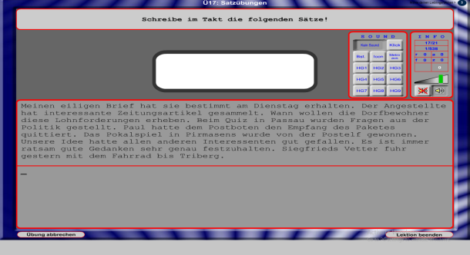

Both are different. Screen is totally different as compared to original

BOOK-9 LESSON-3 UNIT-18

***NEED TO IMPROVE ORIGINAL***

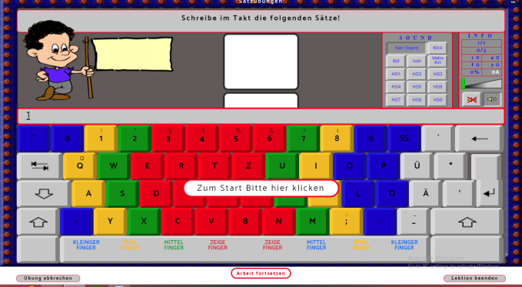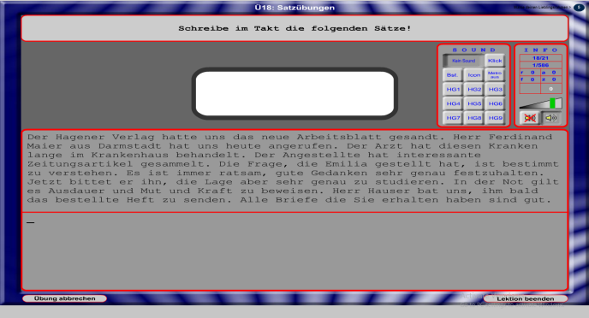

Both are different. Screen is totally different as compared to original

BOOK-9 LESSON-3 UNIT-19

***NEED TO IMPROVE ORIGINAL***

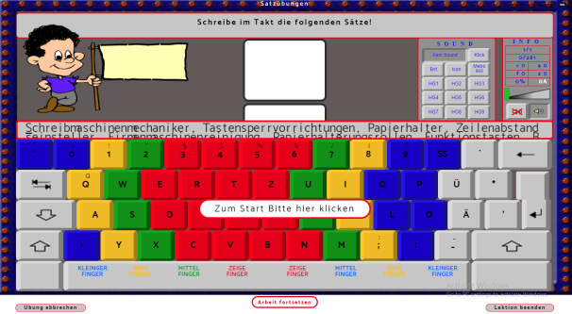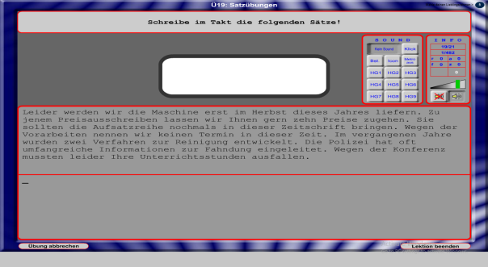

Both are different. Screen is totally different as compared to original

BOOK-9 LESSON-3 UNIT-20

***NEED TO IMPROVE ORIGINAL***

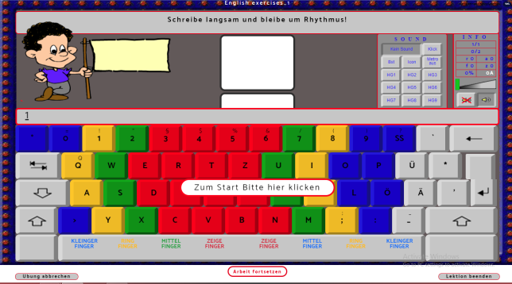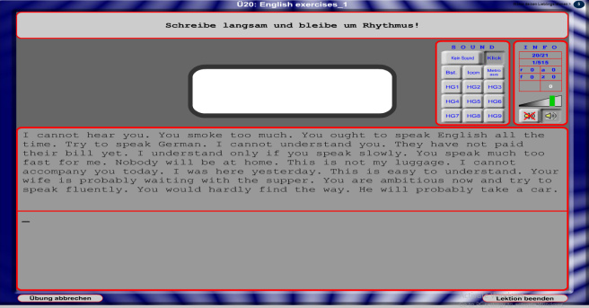

Both are different. Screen is totally different as compared to original

BOOK-9 LESSON-3 UNIT-21

***NEED TO IMPROVE ORIGINAL***

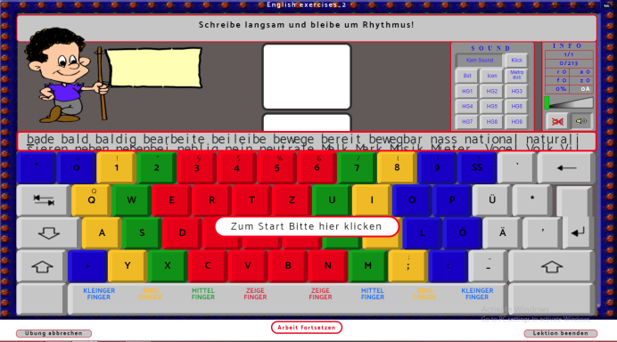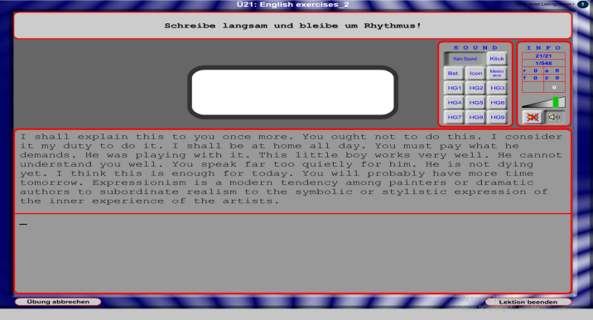

Both are different

MAIN BUGS COMMON IN EVERY EXERCISE

1. Unit no is not mention in the top before the unit name
2. Font size of whole page is different as compared to original
3. Size of cartoon is not proper and blur also as compared to original
4. Cartoon flag have different text and blank also as compared to original
5. If we open a unit then it shows keyboard and in original it shows the content so both are different
6. Pop up message is showing in between the keyboard
7. As text written in the text box above the keyboard is different
8. After playing the game it is not showing any result as compared to original
9. Album button is also not working
10. Exercise is not proper if in original it is having 25 units then in that it shows only 24 units instead of 25
11. Not able to play game in some exercises as contents are not given
12. After clicking on “I” button , not able to open other pages
13. Keyboard keys are not similar and not working properly
14. Last buttons are not working “ubung abbrechen” “lektion beenden”

